WEST BENGAL BOARD OF PRIMARY EDUCATION
(An autonomous body established in 1975 under the West Bengal Primary Education Act, 1973) APC Bhawan, DK-7/1, Bidhannagar, Sector-II, Kolkata – 700 091
Teacher Eligibility Test-2022
(For Classes I-V, Primary)
ELIGIBILITY CERTIFICATE
This is to certify that
Name | PIYALI BHOWMIK |  |  | 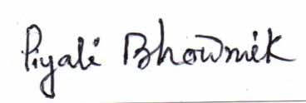WBBPE-TET-2022 PIYALI BHOWMIK TET220136023 2204144  71785  WBBPE-TET-2022 PIYALI BHOWMIK TET220136023 220414471785 WBBPE-TET  -2022  PIYALI BHOWMIK TET220136023 220414471785 WBBP  E-TET-2022 PIYALI BHOWMIK TET220136023 220414471785 WBBPE-TET-2022 PIYAL
Date of Birth | 01-09-2000
Roll No. | 220414471785
Medium | BENGALI
Category | GENERAL
Subcategory
Differently abled
Father’s / Mother’s Name | GOUTAM BHOWMIK
Address | MADHAKHALI BHAGWANPUR II BHUPATINAGAR  BHUPATINAGAR PURBA MEDINIPUR (EAST MEDINIPUR) WEST BENGAL 721425
appeared at Teacher Eligibility Test-2022 (for classes I-V, Primary) c  West Bengal Board of Primary Education and performed as |  |  |  | onducted by the  under :
Subjects |  | Maximum Marks | Marks Obtained | B^^^BP}(}HNI7b3@YB^^^B  4.+$u?CnO4WYnhX%&h.]c5#"#<'  xxLVs:S(gU|}2?47m!er'2N W  LSkC,q_+}goB$-T1j|\)@yY0p  }uuu}EIqE9991Y15}5MIuqqq1AE
Part A : Child Development and Pedagogy |  | 30 | 14
Part B : Language-I (BENGALI) |  | 30 | 26
Part C : Language-II (English) |  | 30 | 16
Part D : Mathematics |  | 30 | 18
Part E : Environmental Studies |  | 30 | 17
Total Marks |  | 150 | 91
Result : |  | QUALIFIED
Examination held on : 11-12-2022 |  |  | Result declared on : 10-02-2023
Bidhannagar, Kolkata – 700 091 |  |  | Date : 29-04-2023
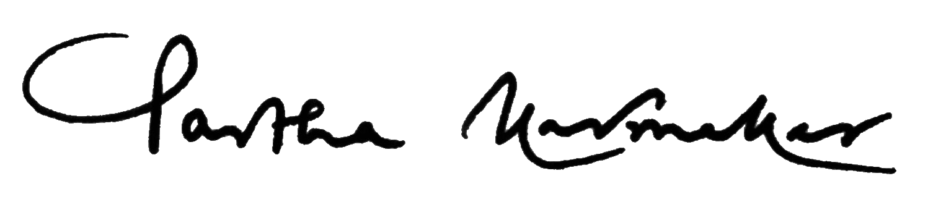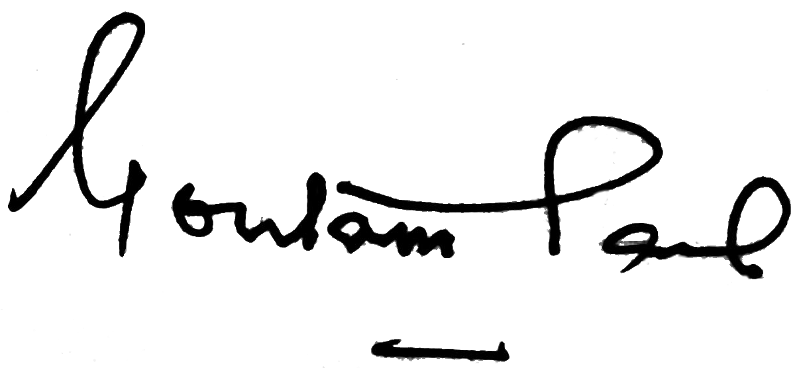
Dr. Partha Karmakar Professor (Dr.) Goutam Paul
Deputy Secretary President
West Bengal Board of Primary Education West Bengal Board of Primary Education
Note :
- All SC/ST/OBC-A/OBC-B/Exempted/Ex-servicemen category and differently abled candidates securing 82 marks (55%) or above out of 150 are declared eligible in the TET-2022 in accordance with extant reservation policy of Govt. of West Bengal and NCTE guidelines.
- All candidates under General category scoring 90 marks (60%) or above out of 150 are declared eligible in the TET-2022 as per NCTE guidelines.
Applicable only for recruitment of Assistant Teachers in Govt. Aided and Govt. Sponsored Primary Schools of West Bengal.
INSTRUCTIONS
- The digitally signed document is legally valid as per the IT Act, 2000 when used electronically.
- The Validity Period of TET-2022 eligibility certificate for appointment, unless otherwise notified by the State Government and/or NCTE, would remain valid for life.
- Qualifying the TET-2022 would not confer a right on any person for recruitment / appointment, it is only one of the eligibility criteria of appointment.
- The eligibility of the candidate has not been verified by the Board. The particulars of the candidate and the subjects are mentioned as per declaration by the candidate in the Application Form of TET-2022 and/or in OMR Answer Sheet. The appointing authority may verify the same before appointment.
  - The TET-2022 shall apply to Govt. Aided and Govt. Sponsored Primary Schools (for classes I – V) under the academic control of the West Bengal Board of Primary Education.
  - TET-2022 may apply to the unaided Private Primary Schools in West Bengal, who may exercise the option of considering the TET(for classes I – V, Primary) conducted by the West Bengal Board of Primary Education.
Certificate No: TET-2022/200066
WBBPE/TET-2022#WBBPE/TET-2022#WBBPE/TET-2022#WBBPE/TET-2022#WBBPE/TET-2022#WBBPE/TET-2022#WBBPE/TET-2022#WBBPE/TET-2022WBBPE/TET-2022

